Converting Old Documents in Sharepoint and OneDrive

Old word documents will show as “.doc” files in OneDrive and Sharepoint. 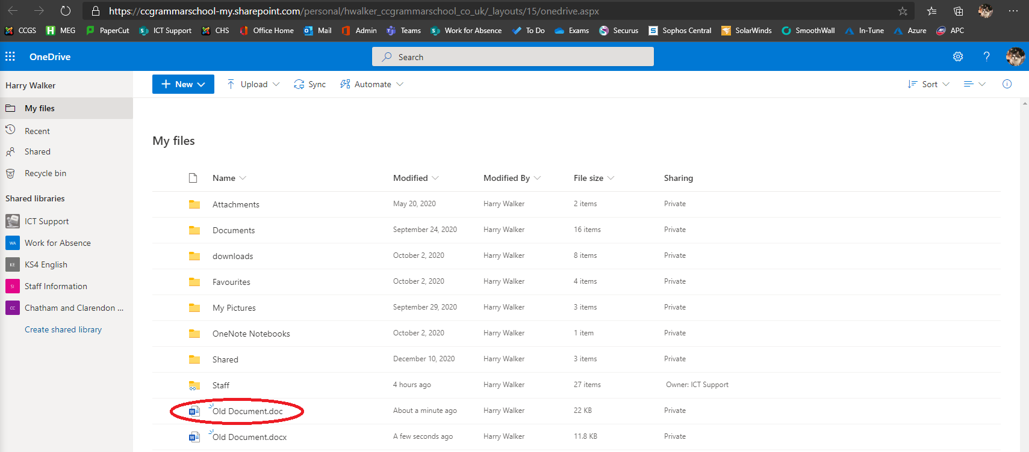
When opening these old files you will be presented with a read only document.
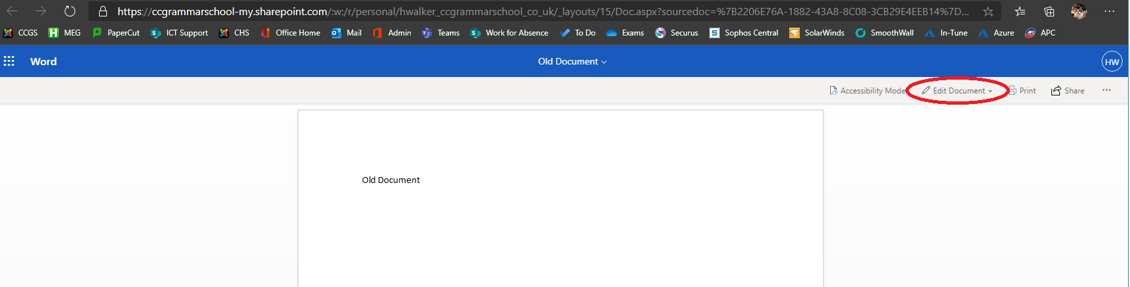
Click the highlighted “edit document” button above and then choose “edit”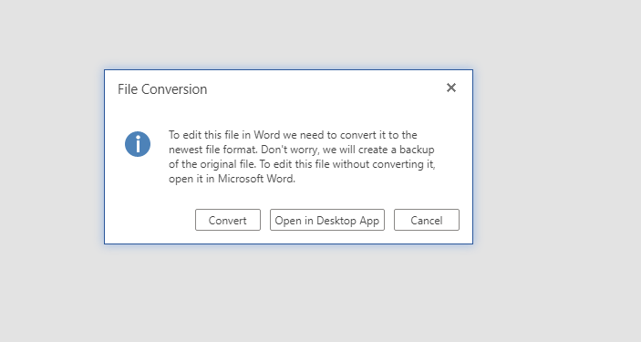
Choose Convert in the above image
Then “edit” on the next pop-up
Once you have chosen “edit” this will then open a new document and be saved as a “.docx” in the same directory. 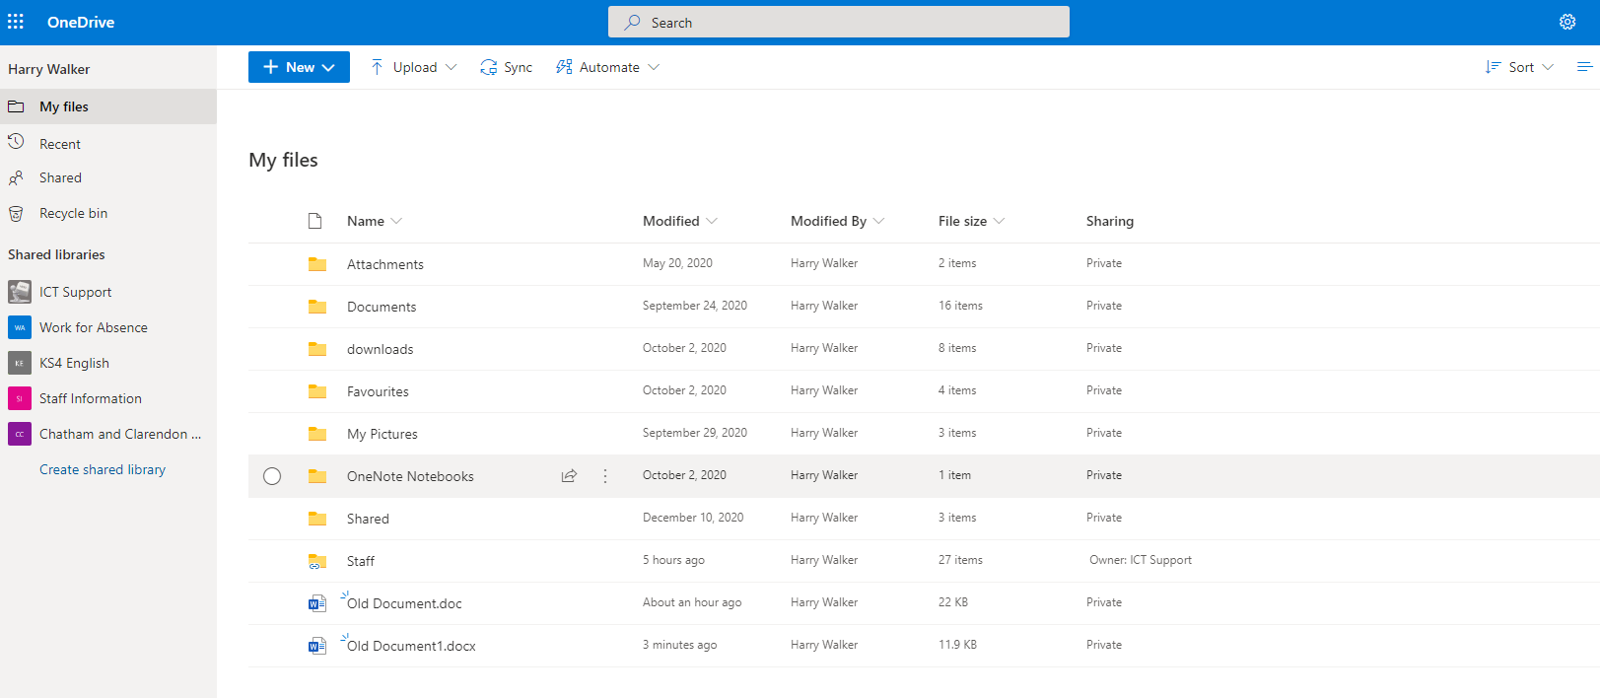
The old “.doc” file is the original and will require converting each time you want to use it.
The new “.docx2 file is the converted file and can now be used instead of the original.

